University of San Carlos (USC) is a Catholic educational institution administered since 1935 by Society of the Divine Word (SVD) missionaries.

A University since 1948, USC offers the complete educational package from kindergarten, including a Montessori academy, to graduate school.

Learn more about Education with a Mission and how we Witness to the Word.

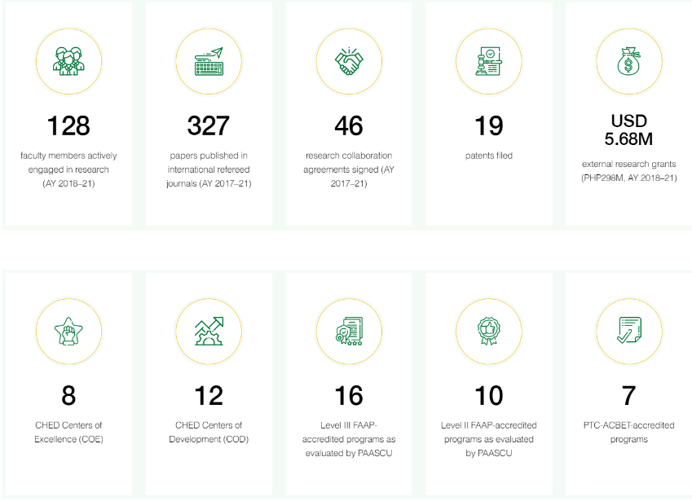

Administered by the Society of the Divine Word (Societas Verbi Divini, SVD) since 1935, the University of San Carlos (USC) traces its roots to the Colegio de San Ildefonso founded in August 1595 in Cebu City.

The school closed in 1769 following the expulsion of Jesuit priests from the Philippines, and was reopened in 1783 as Colegio-Seminario de San Carlos which operated until the Colegio split from the seminary in 1930.

Following another brief closure during World War II, Colegio de San Carlos became a University in 1948.

Rapid growth in the ‘50s saturated the campus near the city center prompting expansion of the University to what was then called the Boys’ High School in 1956 (now North Campus), and in 1964 to the Teacher Education Center and Girls’ High School (now South Campus) and to Talamban Campus.

In 2008, the erstwhile SVD Formation Center was transformed into the Montessori Campus.

Total land area of the University’s five campuses is almost 88 hectares (or 217 acres), with about 78 hectares in Talamban Campus alone and potentially ample room for future growth.

Today, the University is one of the most respected higher education institutions in the Philippines, offering 45 undergraduate and 62 graduate programs.

Many of these programs have received Level II or Level III accreditation from the Federation of Accrediting Associations of the Philippines (FAAP), as evaluated by the Philippine Accrediting Association of Schools, Colleges, and Universities (PAASCU).

Seven engineering programs are also accredited by the Philippine Technological Council-Accreditation and Certification Board for Engineering and Technology (PTC-ACBET).

The Philippine Commission on Higher Education (CHED) also granted Autonomous Status to the University, and designated eight Centers of Excellence (COE) and 12 Centers of Development (COD) in USC.

Nearly 22,000 students in basic to graduate education are enrolled in the University, with almost 200 international students.

On average, the teacher-to-student ratio at USC is 1:20. USC is ranked between 451 to 500 in the QS University Rankings for Asia 2021.

Recognized as a research hub in southern Philippines, USC has drawn in external grants amounting to PHP298M (USD5.68M) between AY 2018-2021.

Internal research grants of over PHP46M (over USD962T) have also been awarded from the University Research Trust Fund within the same time period.

Research efforts are supported by a print collection of over 200,000 titles and almost 10,000 non-print volumes housed in the University’s Library System, along with subscriptions to 17 online journals.

USC also publishes two respected scholarly journals, The Philippine Scientist and the Philippine Quarterly of Culture and Society.

Additional support for researchers are available through offices or committees providing ethics review, intellectual property and innovation and technology support, and animal care and use.

Nineteen patents have been filed by the University since 2012, and one start-up company, Green Enviro Management Systems (GEMS), Inc., has been established.

Student support in the University includes an international students’ office, online enrolment, dormitories, numerous cafes and canteens, and a transport system within Talamban Campus.

USC has more than 600 undergraduate and graduate scholars at any given time.

Since 2014, USC has been designated as a Donee Institution by the Philippine Council of Non-Governmental Organization Certification (PCNC).

**Vision**

The University of San Carlos sees:

A WORLD where the darkness of sin and the night of unbelief vanish before the light of the Word and the Spirit of grace

A SOCIETY where citizens are competent, noble in character and community oriented:

What they know, they apply justly and honestly.

What they do not know, they seek to learn.

What they do not have, they endeavor to acquire.

What they have, they share.

**Mission**

The University of San Carlos is a Catholic Institution of learning that embodies the principles of academic discipline of San Carlos Borromeo and the missionary charism of the Society of the Divine Word (SVD).

We aim to develop competent and socially responsible professionals and lifelong learners in an environment that fosters excellence in the academic core processes of teaching-learning, research, and community extension service.

Our mission is to provide timely, relevant, and transformative academic programs responsive to the needs of the local, national and global communities in rapidly changing world.

**SVD Philippines Southern Province**

SVD confreres in the Philippines Southern Province (PHS) are involved in education, formation, and pastoral work. USC is the largest educational institution in the SVD Philippines Southern Province.

**SVD Generalate**

Societas Verbi Divini (SVD) or the Society of the Divine Word is a missionary congregation founded in 1875 by St. Arnold Janssen. Today, SVD priests and brothers serve in 55 countries, including the Philippines where it is recognized as the largest male religious congregation.

**Catholic Identity**

The University’s Catholic identity is embodied in two statements, Education with a Mission and Witness to the Word.

USC aims at the holistic formation of the individual that enlightens the mind, hones skills, and positively transforms character and behavior (from Dialogue with the Word, SVD Education Ministry as Mission of Dialogue, 2010, 103–104).

Every Carolinian becomes a catalyst towards the realization of the kingdom of God, promoting truth, love, justice, freedom, peace, and grace.

Carolinians in society have a sense of mission recognizable by their contribution as the “light,” “salt,” and “yeast” of the Gospel.

Graduates of USC are professionally competent and skilled (Scientia), have noble character and are value-driven (Virtus), and are dedicated to social transformation (Devotio).

**Core Values**

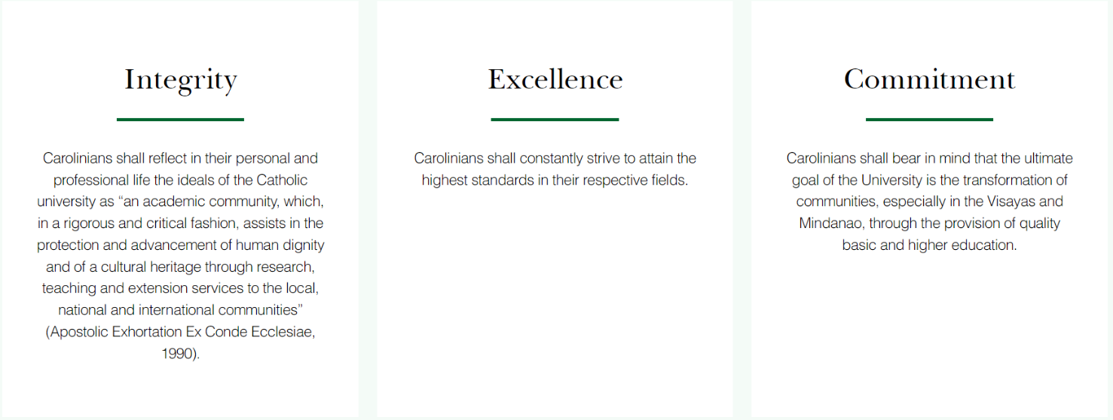

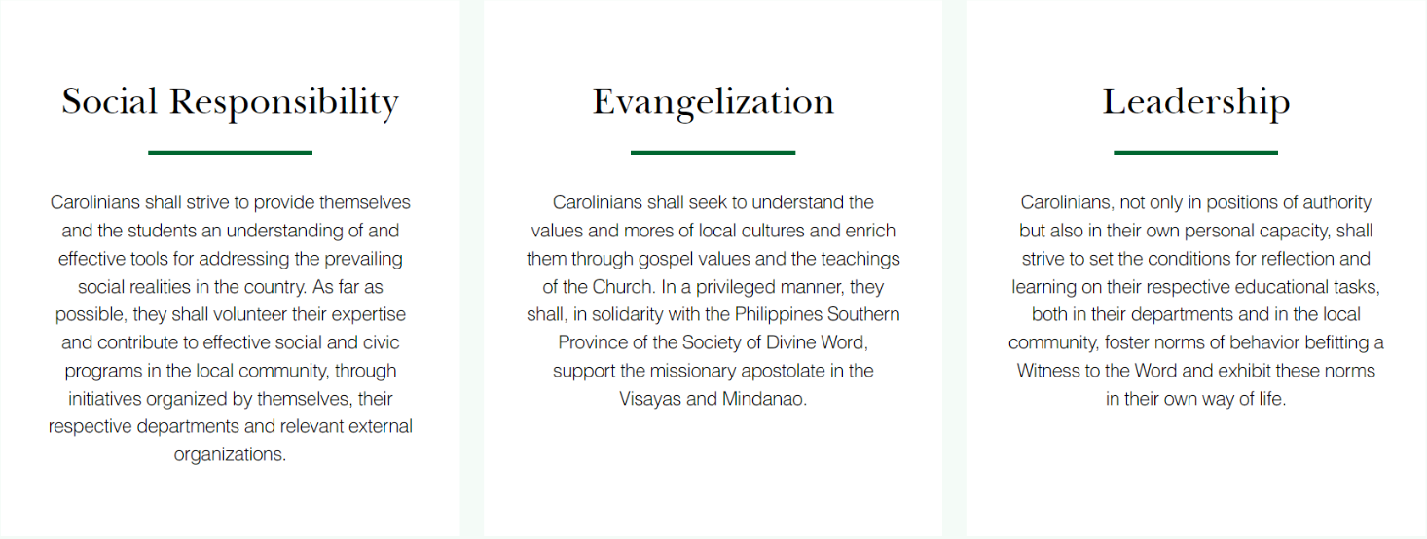

**Board of Trustees**

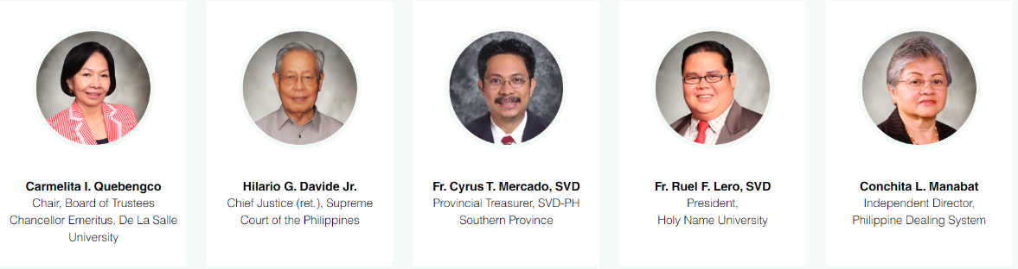

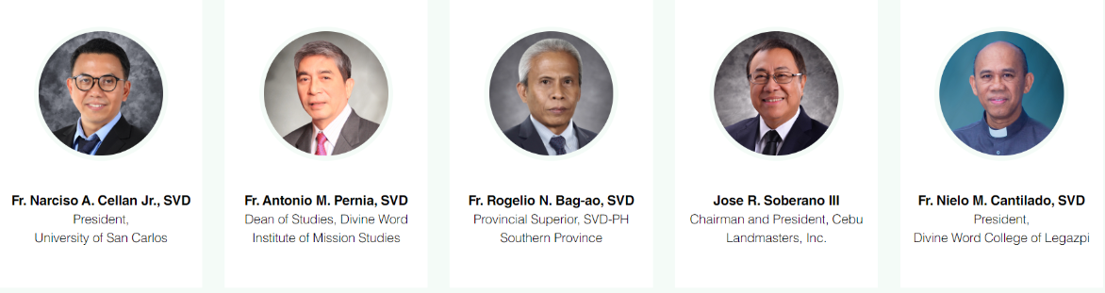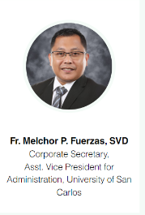

**USC Cabinet**

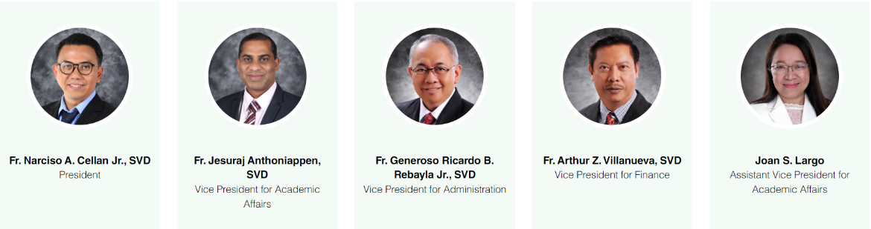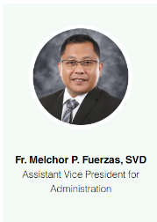

**The University has been granted by the Philippine Commission on Higher Education (CHED) Autonomous Status, which recognizes USC's “track record of exceptional program performance and institutional quality.”**

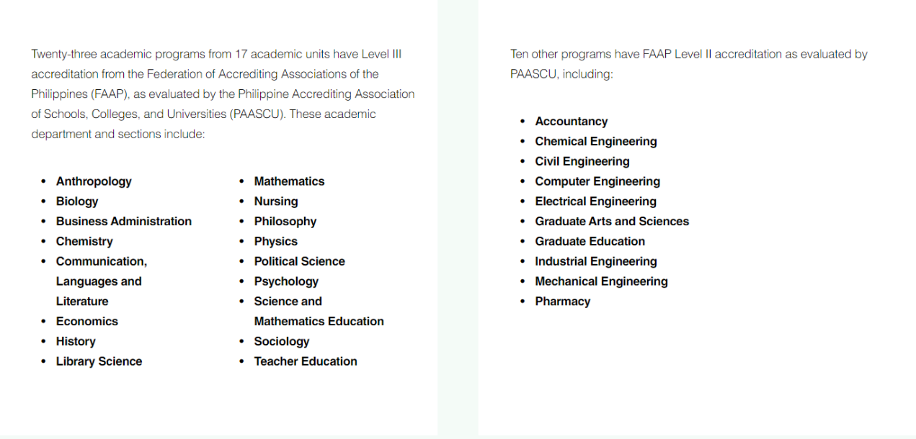

Seven engineering programs (chemical, civil, computer, electrical, electronics, industrial, and mechanical engineering) have received full accreditation by the Philippine Technological Council-Accreditation and Certification Board for Engineering and Technology (PTC-ACBET).

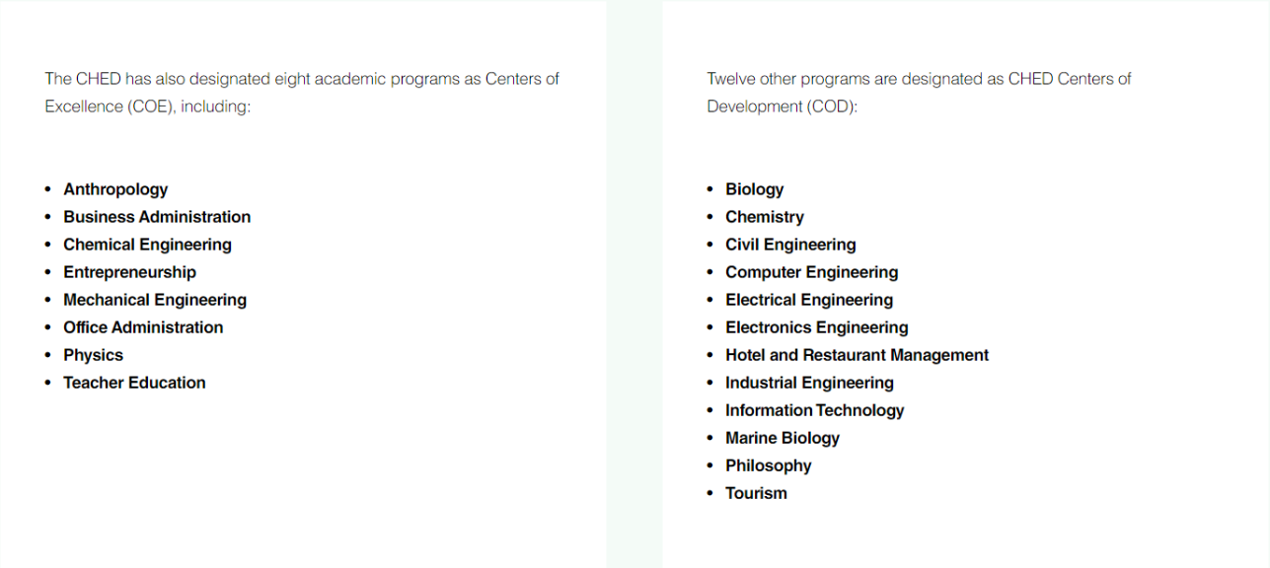

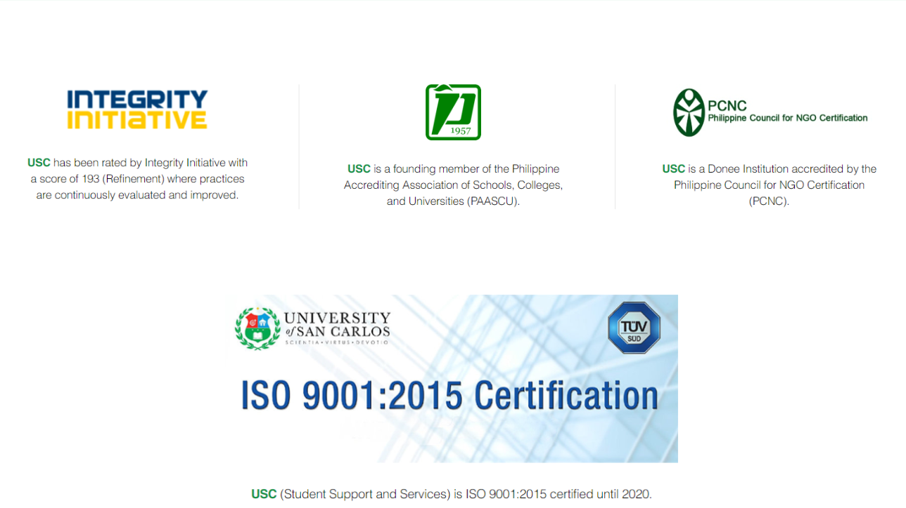

**USC reaps CHED awards**

The University of San Carlos was given six awards by the Commission on Higher Education (CHED) during the celebration of the First National Higher Education Day and the 27th Founding Anniversary of the Commission held from May 17 to 24, 2021.

The University was cited for Exemplary Leadership, Institutional Performance in the QS Asia University Rankings, Program Excellence for its Centers of Excellence (COEs) and Centers of Development (CODs), and for Institutional Excellence as an Autonomous Higher Educational Institution (HEI). The Commission also cited USC as a partner for quality assurance in higher education.

University President Fr. Narciso A. Cellan Jr., SVD, D.Comm. received the awards during the blended (face-to-face and virtual) awarding ceremony held on May 22, 2021. Actual attendance for local HEI heads at the Activity Center of the Cebu Normal University was limited to 50 persons. Heads of HEIs from elsewhere in the region attended via video conferencing.

STUDENT SUPPORT SERVICES

In support of academic instruction, the University of San Carlos' Student Support and Services, as an integrated system, is committed to the delivery of quality services and programs essential in the formation of Carolinian graduates who are envisioned to become productive citizens of the country and the world.

We are committed to continuously improve our services, processes and our quality management system for the enhancement of student experience in the university; this may require the participation of our suppliers and other external providers of processes and services.

Feel free to access our dedicated portalLinks to an external site. to learn more.

Caloy is the client-facing and interactive version of the Quality Management System documentation of USC's student support and services.

It is an innovative visual communication tool specially designed for Carolinians to assist them when navigating for locations, processes and services around the campus.

Amidst the pandemic, the “Caloy on the webLinks to an external site.” was launched so that Carolinians can access it remotely.

**DCISM**

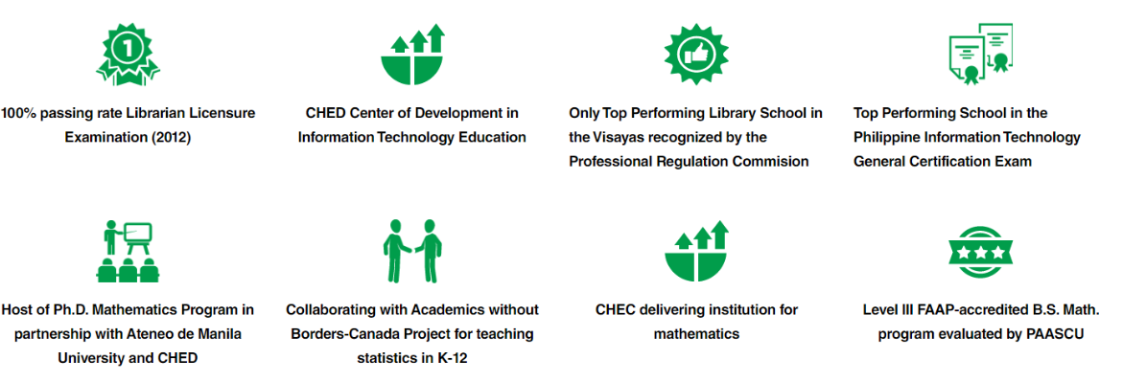

**Overview**

The long history of the Department of Computer, Information Sciences, and Mathematics (DCISM) began with the establishment of the Department of Mathematics in 1962 with Fr. Michael Richartz, SVD, Ph.D. as the first department chair, with an initial offering of the Bachelor of Science in Mathematics and Master of Science in Mathematics programs to address the lack of college mathematics teachers in the region.

In 1990, the Department of Mathematics was renamed the Department of Mathematics and Computer Science following the introduction of the Bachelor of Science in Computer Science curriculum prompted by strong demand from foreign direct investments and local industries. With the development of wireless technology and in response to the needs of the IT industry, the Bachelor of Science in Information Technology program was also offered in 2000 and the Master of Science in Information Technology program in 2003.

In 2004, the Higher Education Development Project of the Commission on Higher Education identified the Department of Mathematics and Computer Science as a delivering Higher Education Institution for its scholarship grant for Master of Mathematics which aims to improve the quality of mathematics instruction in higher education institutions. Due to the increasing number of students enrolled in Information and Computer Technology, the Computer Science section separated from the Department of Mathematics in 2010 with Jacqueline Fat-Yara as its first chair.

The department is a founding member of the Cebu Educational Development Foundation for Information Technology (CEDF-IT) and Oracle Academic Initiative (OAI). The department was recognized by the Commission on Higher Education (CHED) as a Center of Development for Information Technology Education in January 2016.

Meanwhile, the Department of Library Science was established in 1966 under its first chair, Nenita Po Sy. Library Science as a discipline had an even longer journey, beginning as a minor in the Bachelor of Science in Education program in 1950, then as a Bachelor of Arts program in 1958, while a Master of Science in Library Science program was offered in 1970. Prompted by the Commission on Higher Education, the bachelor’s program became an A.B. in Library and Information Science in 1998, before standardization in 2005 resulted in the offering of the Bachelor of Library and Information Science, the Master of Library and Information Science, and the Master of Science in Library and Information Science programs.

The Department of Computer and Information Science (DCIS) was formed in June 2015 from the merger of two departments, namely Computer Science and Information Technology (CSIT) and Library and Information Science (LIS). In 2019, the official name is already the Department of Computer, Information Sciences and Mathematics (DCISM).

Currently, the Department of Computer, Information Sciences and Mathematics has the following academic sections, namely:

* Computer Science
* Information and Communications Technology
* Information Technology
* Information Systems
* Library and Information Science
* Mathematics

**Programs Offered**

* Master of Science in Information Technology (M.S. I.T.)
* Master of Science in Library and Information Science (M.S. L.I.S.)
* Master of Science in Mathematics (M.S. Math.)
* Bachelor of Library and Information Science (B. L.I.S.)
* Bachelor of Science in Computer Science (B.S. C.S.)
* Bachelor of Science in Information and Communications Technology (B.S. I.C.T.)
* Bachelor of Science in Information Technology (B.S. I.T.)
* Bachelor of Science in Information Systems (B.S. I.S.)
* Bachelor of Science in Mathematics (B.S. Math.)
* Associate in Computer Technology major in Multimedia Technology (A. C.T.-M.T.)

**Career Tracks**

Computer Science graduates are primarily employed as computer R&D professionals, software design engineers, and systems software developers, as well as applications software developers and computer programmers.

Information Technology graduates can find employment as web and applications developers, database administrators, network engineers, information security administrators, systems integrators, and IT auditors. They can also serve as QA specialists, systems analysts, technical support specialists, and computer programmers.

Information and Communications Technology graduates can find profitable employment as web designers, graphic artists, multimedia editors, associate programmers, technopreneurs, computer technicians, database designers, technical network support staff, junior systems administrators, technical service representatives, software testers, technical writers, applications developers, IT officers, and R&D or network engineers.

Employers of our graduates include the following companies:

* Accenture
* Advanced World Systems Inc.
* Alliance Software Inc.
* Azeus Systems Philippines
* Convergys
* Framgia Holdings PTE Ltd.
* Global Zeal
* IBM
* Kyocera
* Lexmark
* NCR
* NEC
* Nerubia Web Solutions Inc.
* NEXT IX
* NPAX Cebu Corporation
* Rococo Global Technologies Corp.
* Savvysherpa
* Sprasia Philippines

Library and Information Science graduates serve as academic librarians, archives managers, audio-visual administrators, database managers, directors of libraries, documentalists, information consultants, information specialists, learning resources coordinators, library system analysts, media specialists, multimedia librarians, school librarians, subject specialists, and teachers of Library and Information Science.

Mathematics graduates work as software design engineers, professors and lecturers, space analysts, insurance analysts, finance and risk analysts, statisticians, programmers, consultants, researchers, search engine optimization specialists, and market analysts in private industries or governments both in the country and overseas including Canada, Australia, Germany, Japan, Taiwan, and the United States.

Employers of our graduates include:

* SavvySherpa
* NEC
* Gaisano Metro
* N-Pax Cebu Corp.
* Advance World System
* Union Bank
* China Bank
* Bank of the Philippine Islands
* Banco de Oro
* Department of Foreign Affairs
* Philippine Amusement and Gaming Corp.
* The Aboitiz Group of Companies
* Social Security System
* B-Meg Philippines
* Insular Life
* Nestle
* Various colleges and universities

**Research Projects**

Building Higher Education’s Capacity to Conduct Eye-Tracking Research using the Analysis of Novice Programmer Tracing and Debugging Skills as a Proof of Concept, a collaborative research project with Ateneo de Manila University

E-Participation 2.0: Connecting Diverse Philippine Populations for Disaster Risk Management with a Toolkit Integrating Text and Speech Analytics, a collaborative research project with National University under Philippine-California Advanced Research Institutes (PCARI) Project Commission on Higher Education

Underwater Video Inspection Systems (UVIS), in partnership with Remote Technology Solutions Pte Ltd (Singapore)